**Field Flume Wax Lake Delta**

Purposes of project:

* Derive functional form of particle interception by vegetation
* Determine how relationship changes when biofilm is present
* Test h0 that interception plays a significant role in delta landform evolution
* Educate the next generation of students about fine sediment transport processes and fluid dynamics
* Increase public understanding of land-building processes in coastal ecosystems

In situ flumes, Wax Lake Delta, LA:

* Upstream region: diverging flow & emerging clonal giants (Phragnites australis, Zizaniopsis milincen, Typha spp., Colocassia esculenta, Polygonum punctatum) **w/out extensive biofilm development**
* Downstream region: sheet flow & water lotus (Nelumbo lutea) **extensively coated w/ biofilm**

Specifications from proposal:

* 10 m long x 1 m wide constructed from 0.2 cm thick PVC sheets
* Sunk into ground around intact vegetation, sealed at edges, held in place by external steel fence posts
* Aligned parallel to flow & opened at both ends
* Removable extensions angled outward at 15o appended to upstream portion, enabling experiments to be run under ambient or enhanced flow
* Contain ADV, LISST-FLOC, and two sampling manifolds placed upstream and downstream in flume
* Sampling intake ports set at multiple water depths & pumped simultaneously via peristaltic pumps
* ADCP at outlet of flume to compute precise flow rates
* Sediment traps w/in canopy & on select vegetation stems
* Settling velocity distributions w/in column as in Larsen et al. 2009a

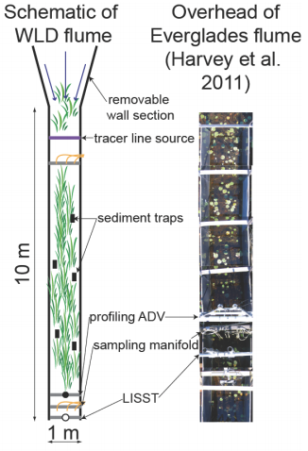

**FLOW ENHANCEMENT:**

Gibbins et al., 2007:

* In situ flume in gravel bed river; focused on patches of bed sediment
* Measured hydraulic conditions and rates of bedload transport
* Max u was 2.14 m s-1
* Designed to be portable with open bottom to isolate patch of stream bed
* Hinged doors at upstream end:
  + 2 positions
    - Normal position: parallel to sides of flume
    - Open position: funneled water from 2-m wide section into flume, increasing discharge and altering hydraulic conditions
  + Perspex sheet slid vertically to further increase velocity and shear stress
    - Slid to fixed position leaving 15 cm gap between bottom of Perspex and stream bed
    - Once positioned at start of experiment was not moved
    - Perspex effects calculated using vertical velocity profile gradient for shear stress
* At 0.4d velocity before manipulations was .53 m/s and after was .96 m/s
* At 0.2d velocity before manipulations was .39 m/s and after was .86 m/s

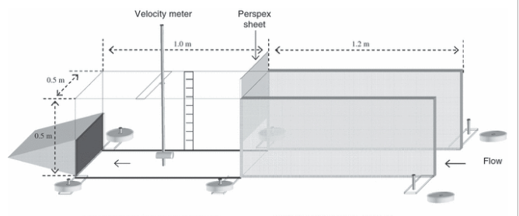

Vericat, 2008:

* Same flume as Gibbins with thinner walls (1 cm) & light, smooth material (Perspex) to limit flow disturbance

Huang, 2008:

* Everglades: wetland, so maybe closer to what we want
* 4.8 m long and 1 m wide
* Open to ground surface & at upstream end; long axis parallel to ambient flow
* 0.2 cm thick PVC sheets framed in steel posts and driven 0.1 m into peat
* Boardwalks along one side of each flume and between two flumes for instrumentation space and access for water sampling
* Steady flow maintained under forced gradient conditions
* Radial flow w/in 0.5 m of withdrawal wells but uniform and parallel w/ flume walls further upstream

Harvey, 2011:

* Everglades
* Relatively large field flume (7.3 m long by 1 m wide)
* 0.2 cm thick PVC sheets inserted 0.1 m into peat; held in place by external steel fence posts driven 0.75 m into peat
* Both ends open
* Removable wall downstream w/ centrifugal pumps (withdraw at 0.67 m3 min-1)

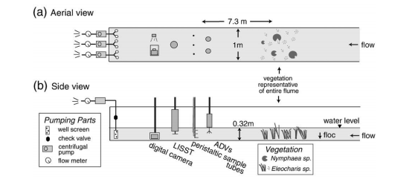

* Flow laminar in first two steps (1.7 & 3.2 cm/s), laminar in 3 & 4 (5.3 & 5.7 cm/s), vortex shedding at last steps

OTHER IDEAS:

* Some sort of removable grid or funnel insert at start of flume to concentrate flow
* Funnel idea would be similar to pumps but opposite; not sure how that translates to the radial effects downstream
  + Three funnels spaced equally laterally and fed through a whole in a Perspex or PVC sheet.

**INSERT FIGURES**

**PARTICLE CAPTURE:**

General ideas:

* Somehow need to capture horizontal portion captured on stems
* Will be difficult b/c have to deal w/ blocking flow and biofilm effects
* Flexible rods (straws? b/c vegetation in everglades was like straws) coated in a sticky substance, synthetic biofilm, or actual biofilm
* Grid mesh so flow can go through but sediment trapped
* Cylinder with front open for sediment capture, similar to BSNE samplers in desert from Fryrear, 1986/ Field et al., 2012
* Cut and wipe and desiccate stems similar to in Everglades

Issues are that the stems are probably ‘capturing’ different volumes and size distributions of particles in different portions of the flow

* How to compare ‘stickiness’
* How to remove particles from the sticky
* Does organic vs. non-organic matter? or what are we considering sediment?

Gacia, 1999:

* Seagrass beds as sinks for fine particles
* Used sediment traps
* 20.5 mL cylindrical glass centrifugation tubes with AR of 5 (16 mm diameter)
* Attached by groups of 5-30 cm long stainless bars & mounted w/ separation of 4 cm from each other
* Triplicate sediment traps for estimates of total depositional fluxes fixed at 20 cmab

Palmer, 2004:

* Cylindrical rods of Delrin varying diameter
* Coated in 2-3 mm thick clear silicone grease (ChemPlex silicone compound 710 by NFO Technologies) & excess wiped off
* Measure “capture” w/ camera & counting → need a better method for volumetric/non-particulate capture
* **Could grow biofilm directly on straws → release fluorescent particles so get volume of particles captured with the fluorometer → or could subtract out mass before particle release**

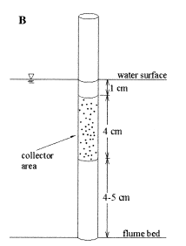

**Summary/Suggestions:**

Overall flume design:

* Keep original design from proposal
* Make two ‘permanent’ flumes with a walkway/boardwalk to allow easy access of the equipment

Flow Enhancement:

* Either pumps circa Harvey et al. or the ‘v’ funnel and one of the insertable ideas in the last bullet of that section

Particle Capture:

* Sediment plates for settling portion
* Palmer et al. style rods using fluorescent particles to get at the mass captured
  + Could even compare what is caught on the synthetic biofilm rods to that caught on the actual stems in flow if using fluorescent particles

Exploratory work by DB following meeting with Laurel:  
Overall flume design:  
• Mostly follow original design from proposal  
• Use pumps from USGS to increase flow rather than the proposed ‘v’ funnel

• Sharpen bottom of panels for easier insertion

Materials for side panels:  
• 48” (1.22 m) by 96” (2.44m) sheets of plastic (4 x side, 16 total)  
Options:  
 PVC sheet has excellent corrosion resistance and weather resistance. The working temp is 33°F to 160°F. and the forming temperatures of 245°F. It is good electrical and thermal insulator and has a self-extinguishing per UL Test 94. PVC applications are almost unlimited. It's the most widely used member of the vinyl family. It is excellent when used for corrosion-resistant tanks, ducts, fume hoods, and pipe. Ideal for self-supporting tanks, fabricated parts, tank linings, and spacers. It is not UV stabilized and has a tolerance of +/- 10%. Not FDA approved materials. Sheets larger then 38" x 48" must ship motor freight.  
  
 1/8” (0.32 cm) thick clear PVC sheet (30lbs/sheet, $164/sheet), available from http://www.usplastic.com/catalog/item.aspx?itemid=44925&catid=733  
 1/8” (0.32 cm) thick gray PVC sheet (30lbs/sheet, $65/sheet), available from http://www.usplastic.com/catalog/item.aspx?itemid=44945&catid=733  
 1/8” (0.32 cm) thick white PVC sheet (30lbs/sheet, $74/sheet), available from http://www.usplastic.com/catalog/item.aspx?itemid=44119&catid=733  
  
 Polycarbonate sheet is a high impact material with excellent properties that enable this material to be used where many others have failed. It is virtually unbreakable, making its products extremely safe in areas where parts may be exposed to high impact. It is UL listed for burglar resistance and it complies with ANSI (Z97.1) for transparent safety glazing in buildings. Polycarbonate is UV stabilized giving it effective resistance to sun exposure. It has performed well in outdoor applications for 5-7 years. Polycarbonate applications include greenhouses, patio roofs, window glazing, safety guards, chair mats, equipment enclosures, signs, doors, and much more. Polycarbonate is available in clear, frosted and Lexan® Margard®.  
 Lexan™ 9034 uncoated polycarbonate sheet is the standard grade of Lexan™ sheet for transparent protective glazing. High-impact Lexan™ 9034 sheet can be utilized for primary glazing, or on either side of existing glazing for economical protection against breakage or intrusions. A better insulator than glass, Lexan™ 9034 sheet contributes to lower energy costs. It is virtually unbreakable, making its products an excellent candidate for safety in areas where parts may be exposed to high impact. Will withstand -40°F to 180°F continuous and 250°F short term with no load. Forming temperature is approximately 375°F. Excellent thermoforming characteristics. Cold form radius no tighter than 100 times the thickness of the material. Superior fire performance. UL listed for burglary resistance. No UV treated surface. Typical applications include interior applications for industrial and commercial, interior glazing in security areas, fabricated parts, industrial machine guards and much more. Not FDA compliant.  
  
 MAKROLON® GP Polycarbonate Sheet is "Clearly the Right Choice" for any application. MAKROLON® GP polycarbonate sheet meets or exceeds the performance characteristics of any directly competitive product. This polycarbonate sheet has outstanding forming, fabrication and performance characteristics. MAKROLON® GP polycarbonate sheet is UV-stabilized and incorporates both economy and high performance in every sheet. .118" - .187" have a UL 94HB rating. .220" and thicker have a UL 94VO rating making this product cost effective in a wide range of industrial and design applications. When you need clarity, toughness, and endurance, be sure you choose "Made with MAK". Does not meet FDA standards. Thickness tolerance is +/- .05%.  
  
 Transparent, thermoplastic sheet used widely in the point of purchase industry. Products offer superior impact strength over acrylic and cost effectiveness compared to polycarbonate, and offers deep draws, complex die-cuts, and precise molded-in details without sacrificing structural integrity. It die-cuts and punches easily, and can be bonded or fastened with adhesives, ultrasonic welding, or rivets. In addition, Vivak® is easily decorated by painting, silk screening, or hot stamping. Easy to fabricate, form, bond, and decorate, Vivak® PETG sheet products are well suited for a variety of point of purchase and other applications. Forming temperature 250°F. - 320°F. Meets FDA standards. Working temperature -40°F - 150°F. Not UV stabilized. Brake forming and cold bending operations can be used to make simple bends and curved areas.  
  
 Extruded & Cast Acrylic Sheet. More flexible than glass or metals, acrylic is more rigid than many other plastics such as acetates, polycarbonates or vinyls. NOTE: components made of Acrylic sheet should not be exposed to high heat sources such as high wattage incandescent lamps, unless the finished product is ventilated to permit the dissipation of heat. 060" - .220" sheets are extruded, .354" - .944" are cast. Half the weight of glass & more impact resistant. Meets ANSI Z97.1 for use as a safety glazing material. Clear, colorless; light transmittance is 92%. Tolerance: +/- .187" on sizes under 48" x 96". Extruded forming temperature: 290°F-320°F. Cast forming temperature: 340°F-380°F. Extruded temp.: -30°F to 160°F cont. (190°F intermittent). Cast temp.: -40°F to 180°F cont. (200° intermittent). Meets FDA standards.   
  
 1/8” (0.32 cm) thick clear Lexan™ 9034 polycarbonate sheet (24lbs/sheet, $129/sheet), available from http://www.usplastic.com/catalog/item.aspx?itemid=40949&catid=704  
 1/8” (0.32 cm) thick clear MAKROLON® GP Polycarbonate Sheet (25lbs/sheet, $115/sheet), available from http://www.usplastic.com/catalog/item.aspx?itemid= 42230&catid=704  
 1/8” (0.32 cm) thick clear Vivak® PETG sheet (25lbs/sheet, $110/sheet), available from http://www.usplastic.com/catalog/item.aspx?itemid= 31945&catid=704  
 1/8” (0.32 cm) thick clear Extruded Acrylic sheet (25lbs/sheet, $94/sheet), available from http://www.usplastic.com/catalog/item.aspx?itemid= 44606&catid=442  
Materials for side panel connectors:  
• H channels, 3 x 4’ per side, 12 total (or 6 total when 8’ length)  
• U channels, 4 x 8’ per side, 16 total  
Options:  
 PolyMax®  
 Aluminum   
 Acrylic   
 Stainless steel  
  
 PolyMax® H-channel, For use with material 1/16" to 3/16" thick, 8’ length (must cut in half), $10 (60$ total), available from https://www.teksupply.com/contractor/supplies/prod1;ts_polycarbonate_panels-ts_polycarbonate_accessories;pg103260_111951.html  
 Impact Modified Acrylic (Clear UV) H-channel, For use with material 1/8" thick, 8’ length (must cut in half), $6.24 (38$ total), available from http://displayproductsonline.com/3-mm-h-channel-227.html  
 U channel: http://www.dkhardware.com/product-3757-ss954-stainless-steel-1-8-opening-1-4-height-u-channel.html#product-description-section  
 U channel: http://displayproductsonline.com/1-8-in-u-channel-3-175-mm-279.html  
Materials for side posts:  
• T posts (4 x side, 16 total)  
Options: